PROJECT REPORT
On
“Employee Management System”
Submitted in the partial fulfilment of Bachelor of Computer Applications
To Uttaranchal University


Uttaranchal School of Computing Sciences
Session (2025-2026)

Under the Supervision of Submitted by:
Ms. Dimple Chaudhary Ayush Rawat
(Assistant Professor ) Enroll. No. UU2509000113
BCA. II sem.
Section F

ACKNOWLEDGEMENT

The most awaited moment of any endeavor is successful completion, but nothing can be done successfully if done alone. Success is the outcome of contribution and consistent help of various person and we thank those ones who helped us in successful completion of this project.
Primarily would like to thank Prof (Dr.) Sonal Sharma, Director-USCS for providing a healthy and encouraging environment to study.
I profusely thankful to Dr. Sameer Dev Sharma, Head of Department-USCS for their valuable support and guidance to build the project.
I am also thankful to Program Coordinator- BCA 1st Year, Assistant Professor-USCS for providing all the required resources in the successful completion of my project report.
I express my thanks to Ms. Dimple Chaudhary, Project Mentor, Assistant Professor-USCS. She has been generous enough to provide me an opportunity and accepting my project for the most valuable guidance and affordable treatment given to us at every stage to boost my morale.

^{Ayush Rawat}
^{Enroll.No. UU2509000113}
^{B.C.A 2nd Semester}
^{Section -F}

DECLARATION

I hereby declared that the project report entitled “Employee Management System” submitted by Ayush Rawat to Uttaranchal School of Computing Science. The project report was done under the guidance of Ms. Dimple Chaudhary, Assistance Professor-USCS. I further declare that the work reported in this project report has not been submitted and will not be submitted, either in part or in full, for the award of any other degree or diploma in this university or any other university or institute.

Enroll. No. UU2509000113
B.C.A 2nd Semester Section – ‘F’

CERTIFICATE

This is to certify Ayush Rawat student of BCA 2nd Semester, of Uttaranchal School of Computing Sciences, Dehradun, has completed the project Report for the title Employee Management System for the session (2025- 2026).

Under the guidance of: Ms. Dimple Chaudhary
Assistant professor- USCS
Uttaranchal University

Ⅲ

TABLE OF CONTENTS

S.NO. | CONTENT | PAGE NO.
 | Acknowledgement | Ⅰ
 | Declaration | Ⅱ
 | Certificate | Ⅲ
1. | Introduction  1.1Objective of the project  1.2Scope of the project | 01-02  03  04-05
2. | System Analysis/Requirement  - System analysis  - System requirement  - Feasibility Study  - Operational Feasibility  - Economic Feasibility | 06  07  08  09  10  11
3. | Planning  - Project Planning Overview / DFD  - Class Diagram  - Flow Chart  - Ghantt Chart  - Pert Chart | 12  13-16  17  18  19  20
4. | SYSTEM DESIGN AND MODULE STRUCTURE  - Number of Modules and Description  - Data Structures Used in the Project  - Proposed Security Mechanisms | 21-23  24  25-26  27-28
5. | Testing  - Unit Testing  - Integrating Testing  - Sample Test Case | 29-30
6. | Security Mechanism  6.1 System Security Measures | 31
7. | Scope and Further Enhancement | 32-33
8. | Code | 34-38
9. | Bibliography | 39

INTRODUCTION
The Employee Management System is a mini project developed using the C++ programming language to simplify and manage employee -related information in an organization. In many companies and institutions, maintaining employee records manually can be difficult, time -consuming and prone to error. Therefore, this project is designed to provide a simple, efficient, and user-friendly solution that helps manage employee data through a console -based interface. The system allows users to add employee records, view employee details, update information, and delete records whenever required.
The main purpose of this system is to demonstrate how programming concepts can be applied to solve real-life problems in an organizations. This project uses basic C++ concepts such as structures, arrays ,. Loops, functions , and conditional statement to build a functional employee management application . Through this system , users can easily organize and maintain employee information such as employee ID , name , salary , and other basic details . It also allows multiple operations like searching for an employee records , editing employee data , and displaying all employee information in a structured format .
In this system , each employee is assigned a unique identification number which helps in manging and accessing records efficiently. When helps in managing and accessing records efficiently . When the program starts , the user can select different options from the menu such as adding new employee details , modifying employee , viewing existing employee details , modifying employee records , or deleting employee data . This structured approach makes the management of employee information simple and organized while reducing the chances of duplication or data loss.
The Employee Management system also help improve data accuracy and save times by automating the process of maintaining employee records. Instead of handling paper work or maintain physical files, organization can store employ detail digitally and access them quickly whenever required. The system also provides confirmation messages for successful operation like adding , updating , or deleting employee records , which makes it easier for
users to interact with the system .
To make the system more interactive and visually appealing, the project includes colour formatting, simple menu -driven interface , and a well -structure layout. These features improve user experience and make the console interface more attractive and easier to understand and operate . The system also provides feedback messages for successful operations such as adding employee records , updating employee details , deleting employee information , and handling possible errors . These message help users interact smootly with the program and understand the result of their actions
This project is useful for understanding how a real-world employee management system works in a simplified way. It helps students learn about data storage , record management , and basic administrative operations in an organization . Through this system , users can manage employee information such as employee ID , name , position , and salary in an organized manner .The Employee Management system can be further enhanced by adding advanced features such as file handling , database connectivity , attendance management , payroll calculation , and a graphical user interface to make the system more powerful and practical .
I conclusion, this mini project provides a practical example of how programming can be used to create a functional management system. It not only improves coding skills but also helps in understanding the design and development of real-life software applications. The system is simple, efficient, and suitable for academic purposes, making it a valuable learning project for students studying C++ and software development fundamentals.

1.1OBJECTIVE OF THE PROJECT

The objective of employee management using C++ is to develop a computerized system that efficiently stores, organizes, and manages employee data such as names, IDs, salaries, and departments. It aims to automate routine tasks like adding, updating, deleting, and searching records, thereby reducing manual effort and minimizing errors. By using features of C++ such as classes, file handling, and object-oriented programming, the system ensures structured data management, fast access to information, and improved accuracy. Additionally, it helps maintain data security and supports scalability so that the system can handle a growing number of employees, making overall management more reliable and efficient.

1.2 SCOPE OF THE PROJECT

The scope of the Employee Management System project includes the design and implementation of a console – based application using C++ for managing employee records in small and medium -sized organization . The system provides a comprehensive set of features for handling employee -related information effectively . The key scope areas of the project are as follows;
- Employee Information Management
- To maintain complete employee records in the system .
- Store employee personal details such as name ,address , and contact number.
- Maintain employee ID , department , and designation information.
- Keeps records of employee joining date and job role .
2. Employee Record Operations
- To manage employee data efficiently through different operations.
- Add new employee records into the system .
- Update existing employee information when required.
- Delete employee records that are no longer needed.
- Display and view employee details easily.
3. Data Storage and Management
- To store employee information in a structured and organized format .
- Use file handling in C++ for data storage .
- Maintain a centralized records of all employees.
- Ensure proper organization of employee data .
4. Data Retrieved and Search
- To provide quick access to employee information.
- Search employee records using employee ID or name .
- Display employee details quickly when required .
- Improve accessibility of employee records .

2. SYSTEM ANALYSIS/REQUIREMENT

The Employee Management System is a console-based application that can run on a basic computer system without the need for high-end hardware. To execute the program smoothly, a computer with at least an Intel i3 processor or any equivalent processor is recommended. The system should have a minimum of 4 GB RAM to ensure that the application runs without lag and handles user input and seat data efficiently. Around 100–200 MB of free disk space is sufficient to store the source code, compiler, and related project files. A standard keyboard and monitor are required for entering employee details, updating records , and viewing employee information through the console interface . Since console -based features and text display ,it works well on systems running the Windows operating system, such as Windows 7, Windows 10, or later versions. Any system capable of running a C++ compiler can support this project, making it suitable for most college computer labs and personal laptops.
From a software perspective, the system is developed using the C++ programming language and requires a C++ compiler or integrated development environment (IDE) such as Code::Blocks, Dev C++, Turbo C++, or Microsoft Visual Studio. The program utilizes standard C++ libraries like iostream for input and output operations, vector or arrays for storing employee records ,and iomanip for formatting the displayed data in an organized manner. The application runs in a command-line environment and does not require internet connectivity or external server support, as all data is processed and stored temporarily in memory during runtime. However, for future expansion, the system can be enhanced by adding file handling or database integration to store employee records permanently. Overall, the project has minimal system requirements, making it easy to install, compile, and execute on most computers used by students for academic and learning purposes.

2.1 SYSTEM ANALYSIS

System analysis is the process of examining the current system and identifying its limitations and problems. In many organizations , employee records are still maintained manually using registers or paper files . This traditional method becomes inefficient as the number of employee increases. Managing employee information manually can lead to errors , data loss , and difficulty in updating or retrieving records when needed .
The Employee Management System is designed to simplify the process of managing employee information in an organization . The system analyses the need for an organized method to handle employee records such as personal details , job position , salaries , attendance , and other related information without manual errors. In traditional manual systems, maintaining large amount of employee data can be confusing and time -confusing. Therefore, this computerized system helps store and mange employee data accurately and efficiently .
The system mainly focuses on managing employee records and ensuring easy access to information . It allows users or administrators to add new employee information , and delete unnecessary records when required . Each employee is assigned a unique ID number , which helps in identifying and managing their data easily . The system ensures that all employee information is stored in an organized format and can be accessed quickly whenever needed.
From a technical point of view, the system is built using C++ programming language and uses programming concepts such as structures, arrays, loops, and functions. All employee data is stored temporarily in memory during program execution. The system is suitable for small-scale organizations or academic projects and serves as a basic model of a real -world employee records management system . It provides a simple, efficient, and user-friendly solution for managing employee information in an organized manner.

2.2 SYSTEM REQUIREMENT

1. Hardware Requirements

A computer or laptop with at least an Intel i3 processor or equivalent.

Minimum 4 GB RAM for smooth execution of the program.

At least 100–200 MB of free disk space for storing project files and the compiler.

Standard keyboard for entering employee data and system commands .

Monitor or display screen for viewing employee records and system output.

2. Software Requirements

Windows operating system (Windows 7/8/10/11 recommended) for running the program.

A C++ compiler such as Code::Blocks, Dev C++, Turbo C++, or Visual Studio.

A basic console/command prompt environment to run the application.

3. Functional Requirements

Allows the user to enter and store new employee details .

Shows all stored employee using an employee ID .

Enables the user to find a specific employee using an employee ID.

Allows modification of existing employee information .

Removes employee data that is no longer required .

4. Non-Functional Requirements

The system should process employee data quickly and display results without noticeable delay.

The system should function correctly during execution and handle employee records without data errors.

The application should have a simple and user-friendly interface so that users can easily add , update , search , and delete employee information .

Only authorized users should be able to access and modify employee records to protect sensitive information .

The system should be able to handled an increasing number of employee records without affecting performance .
  - Feasibility Study

The feasibility study of the Employee Management System evaluates whether the project is practical, cost-effective, and technically possible to implement. This system is developed as a console-based C++ application, making it easy to design and execute without requiring advanced hardware or expensive software tools. The project aims to replace manual record keeping with a computerized system that improves accuracy , reduces paperwork , saves time . The proposed system is simple and requires minimal resources to develop and operate . It is suitable for small organizations , offices , and academic purposes . The system can be easily implemented using standard computer systems and basic programming tools .
2.3.1 Technical Feasibility
The technical feasibility of developing an Employee Management System (EMS) in C++ is quite practical, as C++ is a powerful and efficient programming language suitable for handling structured data and complex operations. Using features like classes, objects, file handling, and data structures, an EMS can be designed to manage employee records such as personal details, salary, and attendance. The system can store data in files or use database connectivity (e.g., MySQL with C++ connectors) for persistent storage. Since C++ is widely supported and can run on standard hardware without requiring high-end resources, it ensures smooth implementation.
Additionally, the required technical knowledge—such as object-oriented programming, file handling, and basic database concepts—is commonly available among developers and students. The system can be expanded to include features like search, update, and delete operations, making it scalable and flexible. Security can be managed through controlled access and validation techniques, while performance remains high due to C++’s efficiency. Therefore, developing an Employee Management System in C++ is technically feasible and suitable, especially for small to medium-scale applications or academic projects.
2.4 Operational Feasibility
Operational feasibility of an Employee Management System developed using C++ focuses on how well the system will function within an organization’s day-to-day activities. Since C++ is a high-performance programming language, it can efficiently handle employee data such as records, attendance, payroll, and performance details with speed and accuracy. The system can be designed with a simple console-based or file-handling interface, making it suitable for small to medium-sized organizations that do not require complex graphical interfaces. Employees or administrators can easily input, update, and retrieve data, reducing manual paperwork and minimizing errors.
From an operational perspective, the system is feasible because it requires minimal resources to run and can be maintained with basic programming knowledge. Training staff to use a C++-based system is relatively straight forward if the interface is kept user-friendly. Additionally, the system can be customized and scaled as organizational needs grow, such as adding new modules for leave management or salary calculations. Overall, the use of C++ ensures reliability, efficiency, and cost-effectiveness, making the Employee Management System practical for real-world implementation.
  - Economic Feasibility
- Economic feasibility determines whether the project is financially viable and whether the benefits justify the costs .

- The project does not require expensive hardware or advanced equipment.
- It can run on a standard computer or laptop available in the institution.
- No additional external devices are required to operate the system.
- The system is developed in C++, which is freely available and requires no paid license.
- The system is developed in C++ , which is freely available and does not require a paid license.
- Development costs are very low because the project is designed as an academic mini-project.
- Maintenance costs are minimal because the system is simple and easy to update.
- No internet connection or server infrastructure is required for the basic version of the system.
- The system reduces the manual work involved in maintaining employee records .
- It improves efficiency in managing employee data .
- It is suitable for small organizations , offices , and educational purposes.

PLANNING
The planning phase is an important stage in developing the Employee Management System. It focuses on defining objectives, identifying system requirements, and developing a structured approach to ensure the successful completion of the project. Proper planning ensures the project is developed in an organized manner and completed within the specified timeframe.
During this phase, the current manual method of managing employee records is carefully studied to understand its limitations and challenges . In many organizations , employee information is maintained using paper files or manual registers . This approach can lead to problems such as difficulty in searching employee details , errors in record keeping , and delays in updating information . By analyzing these issues , the need for a computerized system becomes clear .
The planning stage also involves selecting the appropriate technologies and tools for developing the system. The project will be developed in C++ as a console-based application. Basic programming concepts such as structures, functions, file handling, and menu-driven interfaces will be used to implement the system.
Another important aspect of planning is task scheduling and resource allocation. The project is divided into several phases, including requirements analysis, system design, coding, testing, and documentation. A timeline is prepared to ensure that ach phase of the project is completed within the planned schedule .
Finally, potential risks and challenges are considered during planning, such as incorrect data entry , data management issues , and possible system errors during development. Proper testing and debugging strategies are planned to minimize these risks. Through effective planning, the Employee Management System can be developed efficiently, ensuring accuracy, reliability , and ease of use for managing employee information .

PROJECT PLANNING OVERVIEW
The Project Planning Overview provides a clear roadmap for developing the Employee Management System from initial concept through final implementation. It helps organize the entire development process into structured stages, ensuring that the project to be completed efficiently and within the given timeline.
The first step in the planning process is Requirement Analysis, in which the system's needs are identified. At this stage, the current manual method of managing employee records is examined to identify its limitations , such as difficulty in storing large amount of employee data , errors in record management , and delays in searching or updating employee information . Based on this analysis , the main requirements of the system are defined , including adding employee details , updating records , searching employee information , and displaying employee data .
The next stage is System Design, where the system's structure is planned. This includes designing the flowchart, data structures, and program logic required for the system. The project will use structures to store employee ID, name , department , designation , and salary . Array or vectors will be used to manage multiple employee records . The design phase ensures that the program is organized and easy to maintain .
After the design phase, the project moves to the Development and Coding Phase. At this stage, the program is written in C++. The system is divided into modules, including adding employee records , displaying employee details , searching employee information , updating records , and deleting employee data. Modular programming is used so that each function works independently , making the program easier to manage and debug .
Once the coding is completed, the system enters the Testing Phase. During testing, the program is checked for logical errors, incorrect data handling , and other possible issues . Different test cases are applied to ensure that functions such as adding , updating , searching , and deleting employee records work correctly .
Finally, the project enters the Documentation and Implementation Phase, during which the complete project report is prepared and the system is demonstrated. This phase includes preparing diagrams such as flowcharts, DFDs, Gantt charts, and PERT charts, along with detailed explanations of each module.
Overall, the Project Planning Overview ensures that the Employee Management System is developed in a structured, systematic, and efficient manner, making the system reliable and easy to use for managing employee records.

SYSTEM DESIGN

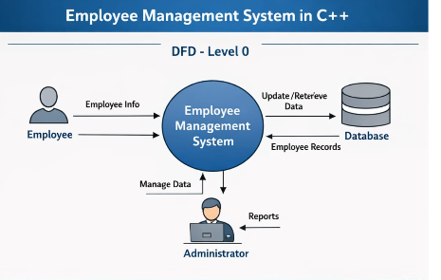

DFD -Level 1

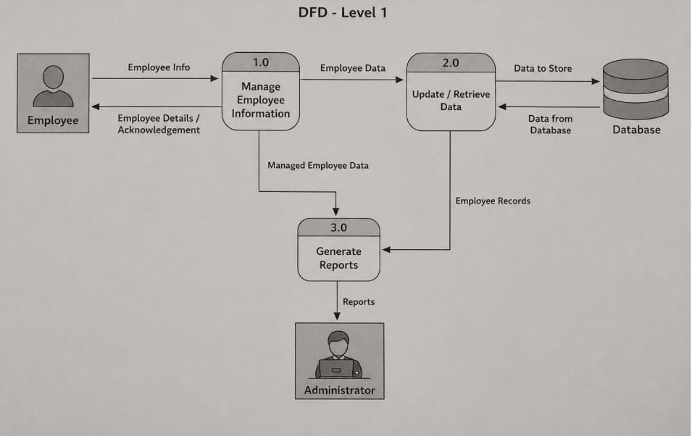

DFD- Level 2

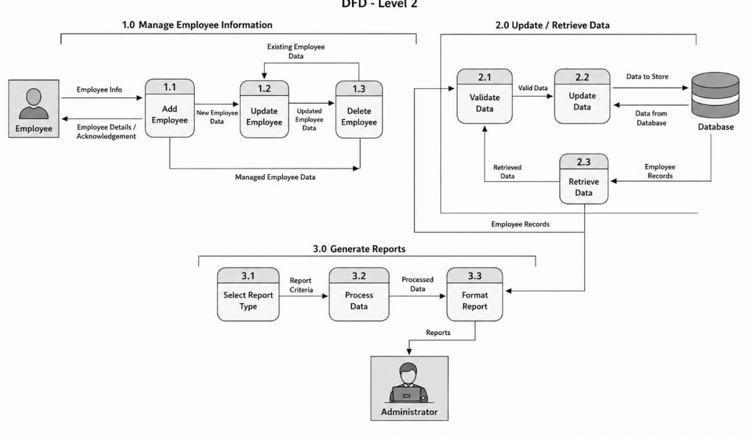

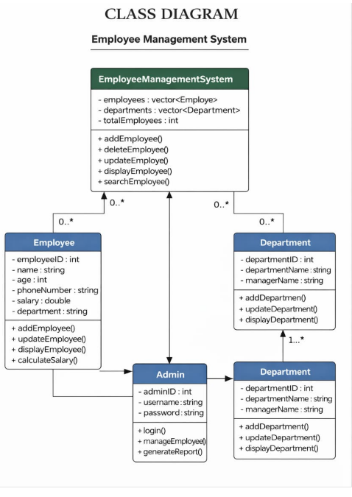

FLOW CHART
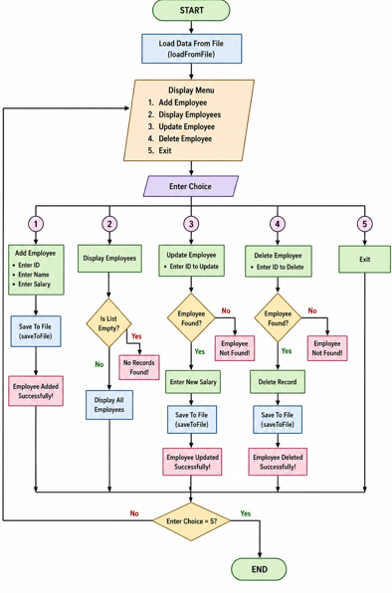

GHANT CHART

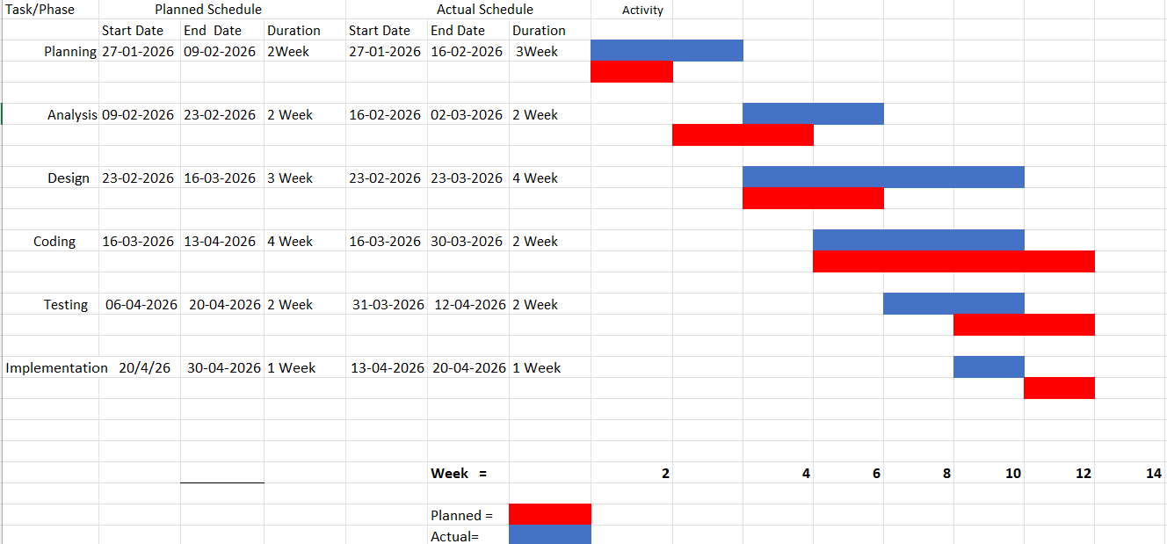

PERT CHART

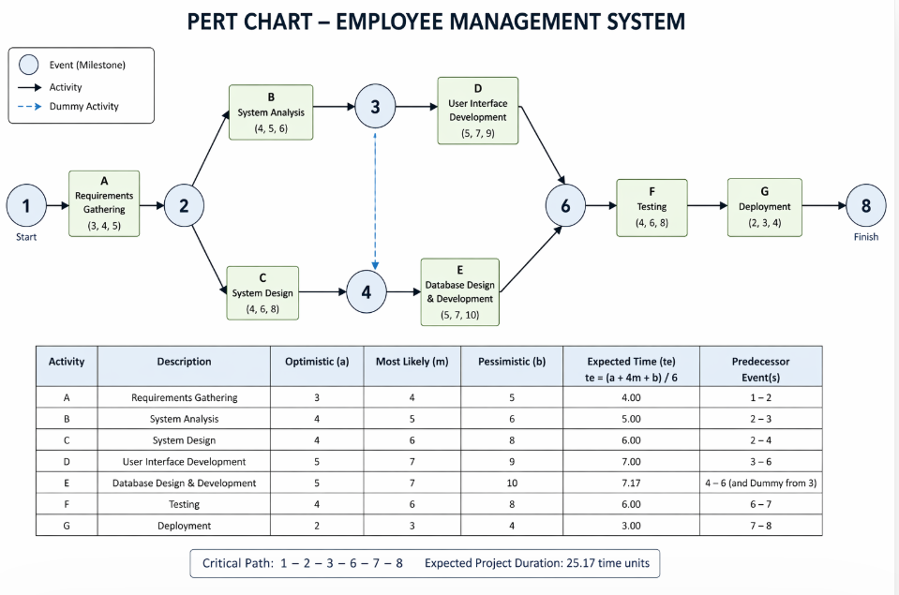

4. SYSTEM DESIGN AND MODULE STRUCTURE

The System Design phase defines how the Employee Management System will be structured and how different components of the system will interact with each other. The purpose of system design is to convert the requirements identified during the analysis phase into a clear and organized blueprint for program development.
In this project, the system is developed as a console-based application using C++, where the user interacts with the system through a menu-driven interface.
The design of the system follows a modular programming approach, meaning the program is divided into smaller functions (modules), and each module performs a specific task. This approach makes the system easier to develop, test, and maintain. The system mainly consists of three layers:
1.User Interface (UI) Layer
- Purpose: Provides interaction between the administrator (user) and the system.
- Responsibilities:
  - Display a clear and user-friendly menu of options:
    - Add a new employee
    - Update employee details
    - Delete an employee record
    - Search for employee information
    - Display all employee records
    - Calculate salaries and generate reports
  - Accept and validate input from the administrator to prevent errors (e.g., invalid phone numbers or negative salaries).
  - Display confirmation messages or errors returned from the processing layer.
2. Processing Layer (Business Logic Layer)
- Purpose: Handles all core operations of the EMS.
- Responsibilities:
  - Add Employee: Validate input, create a new employee structure, and store it in the data layer.
  - Update Employee: Search for an employee by ID, update fields such as department, salary, or contact details.
  - Delete Employee: Locate employee records and remove them from storage.
  - Search Employee: Retrieve employee details based on criteria like name, ID, or department.
  - Calculate Salary: Compute total salary, including bonuses, deductions, or overtime if required.
  - Reports & Analytics: Generate department-wise reports, salary summaries, or employee counts.
- Implementation Details:
  - Functions or methods in this layer communicate directly with the data layer.
  - Handles error checking and data consistency (e.g., avoiding duplicate employee IDs).

3. Data Layer
- Purpose: Stores, organizes, and manages employee information efficiently.
- Responsibilities:
  - Maintain a central repository of employee records.
  - Support fast searching, insertion, deletion, and updates.
- Data Structures:
  - Storage Options:
    - Array: For a fixed number of employees.
    - Vector (Dynamic Array): Allows storage of a variable number of employee records efficiently.
- Additional Options: Linked lists or database integration for very large systems.
  - Example using Vector:
vector<Employee> employees; // stores multiple employee records dynamically

NUMBER OF MODULES AND DESCRIPTION

The Employee Management System is divided into several modules so that the overall system becomes organized, efficient, and easier to manage. Modular design means that the entire program is broken down into smaller functional units where each module performs a specific task.
This approach improves program readability, simplifies debugging, and makes future modifications easier. By separating the system into different modules, the program becomes more structured, and each function can work independently without affecting other parts of the system.
Effort Estimation Table
To estimate the development effort, we use a "Person-Hours" approach based on complexity:
Module Name | Description | Complexity | Estimated Effort (Hrs)
Employee Registration and Login Module | Allows admin to add new employees and mange login access. | Low | 15 - 20
Employee Records Management | Stores and displays employee details such as ID , name , department and salary . | Medium | 30 - 35
Employee Update & Delete | Allows updating and removing employee records from the system . | High | 45 - 50
Salary Management | Calculates and displays employee salary information . | Medium | 20 - 25

Total Effort Estimation
The total estimated effort for the project is approximately 90 to 110 person-hours. This estimation includes the time required for system design , coding , testing , debugging , and documentation of the Employee Management System .
DATA STRUCTURE USED IN PROJECT
Data structures are used in a program to store and manage data efficiently. In the Employee Management System, different data structures are used to handle employee information, department details , and salary records These data structures help in organizing the program and performing operations such as records , deleting data , and displaying employee information smoothly.

1. Structure for User Data
A structure named Employee is used to store the details of each employee. It contains fields such as employee ID , name , age , phone number , department and salary. This structure helps in managing employee records in an organized way . Each time a new employee is added , their details are stored using this structure .

2. Vector for Storing Users
A vector is used to store multiple employee records dynamically. Since the number of users can increase during the execution of the program, the vector allows flexible storage and easy access to employee data . It helps in searching , updating , and displaying employee information efficiently .

3. Structure for Seat Data
Another structure named Department is used to represent each department in the organization . It contains the department ID, department name , and manager name . This structure helps the systems manage departments and associate employees with their respective departments .

4. Array for Seat Management
An array of vectors is used to store employee records in the system . Each element of the array represents an employee object that contains complete employee details . The array makes it easy to quickly access , update , and display employee information whenever required .

PROPOSED SECURITY MECHANISM
The security architecture of the Employee Management System is designed to ensure the confidentiality, integrity, and availability of employee data. By implementing basic protective mechanisms, the system helps prevent unauthorized access and maintains the accuracy of employee records.
• User Authentication and Access Control:
The system uses a login mechanism where the administrator must authenticate using a username and password before accessing the system. Only authorized users are allowed to add , update , or delete employee records .
•Seat Status Protection:
The system stores employee data such as personal information , department details , and salary securely within the program . This helps prevent unauthorized modifications and ensures that employee information remains protected .
•Input Validation:
To maintain system stability and prevent incorrect data entry, the system validates user inputs such as employee ID , phone numbers , and salary details . If invalid data is entered , the system displays an error message and stops the operation .
•Session-Based System Access:
After successful login, the administrator can access the system menu and perform operations such as adding employees , updating records , and viewing employee details . when the users logs out , the session ends , preventing further access without proper authentication .
.Data integrity and record management :
The system maintains accurate employee records by updating information whenever changes are made . This ensures that the employee database remains consistent and
TESTING
Testing is performed to ensure that the Employee Management System works correctly and fulfils all required functionalities. It helps in identifying errors and verifying that each module of the system performs as expected. Different types of testing are carried out to confirm that the system operates smoothly and provides accurate results.

Unit Testing
In unit testing, each module of the system was tested individually to check its functionality. The Employee Registration module is tested to verify that new employees can be added correctly and their details are stored in the system .
The Employee Display module was tested to ensure that all employee information records are shown correctly when requested .
The Employee update module is tested to verify that employee information such as name , department , phone number , or salary can be updated successfully .
The Employee Delete module is tested to verify that employee information such as name, department , phone number , or salary can be updated successfully .
The Salary Management module is tested to confirm that salary calculations and updates are performed correctly .

Integration Testing
After completing unit testing, all modules were combined and tested together to ensure that they work properly as a complete system. The system is also tested under different inputs conditions to ensure that invalid inputs and handled properly and the overall functionally of the system remains stable
Sample test Cases:

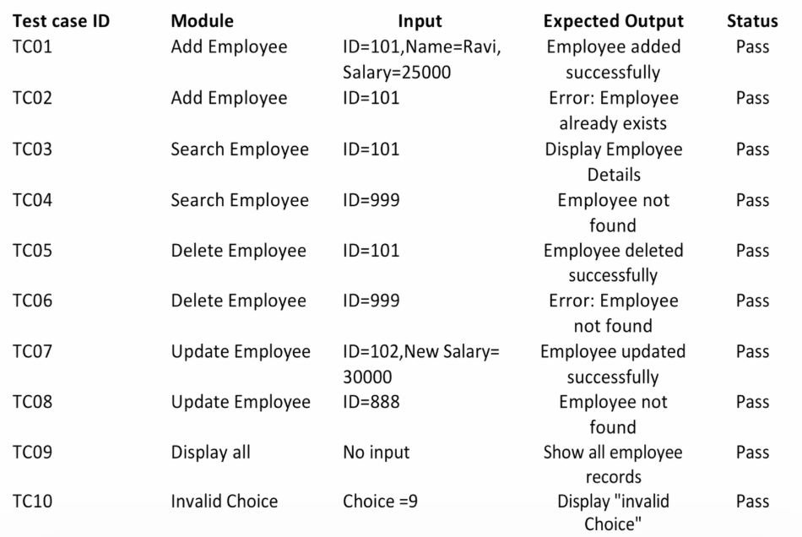
SECURITY MECHANISMS
Although the system is console-based, basic security mechanisms are implemented in the Employee Management System to maintain data integrity and prevent unauthorized access. These mechanisms help ensure that booking records remain accurate and that only valid users can access the system.
The following security measures are included:
• Login Authentication: Access to the system is restricted through a username and password. Only authorized administrators can log in and mange employee records .
• Input Validation: The system checks user inputs to prevent incorrect or invalid data entries. For example, employee IDs must be valid numbers , and salary values must be within acceptable limits..
•Employee Data Protection : Employee records are stored and managed securely within the program . Unauthorized users cannot access or modify employee information
• Data Consistency Checks: The system ensures that employee data remains consistent when records are added , updated , or deleted . All changes are properly reflected in the system to maintain accurate information
SCOPE AND FUTURE ENHANCEMENTS
The proposed Employee Management System is a basic console-based application developed using C++. The system successfully manages essential functions such as adding employees records , updating employee details , deleting records , and displaying employee information . Although the current system performs these basic operations efficiently , there is still significant scope for future improvement and enhancement .
Some possible future enhancements are:

1. Integration with Database
The current system stores employee information in program memory during execution. In the future, the system can be integrated with a relational database such as MySQL or SQLite to store employee records permanently . This will improve data management , security , and scalability while allowing the system to handled a large number of employee records .

2. Graphical User Interface (GUI)
Currently, the system operates through a console-based interface. A graphical user interface can be developed using tools such as Qt, Java GUI, or web technologies to make the system more interactive, user-friendly, and visually appealing.

3. Web -Based Employee Management
The system can be converted into a web-based application so that administrators can manage employee records through a web browser . This would allow access to the system from different locations and devices, making employee management more convenient.

4. Payroll and Salary Management
Future versions of the system can include a payroll management module to automatically calculate employee salaries , bonuses , and deductions. This will help organizations manage employee payments more efficiently .

5. Advanced Employe Management Features
Additional features such as attendance tracking , performance evaluation , department management , and report generation can be introduced .These features will help organizations manage employee data more effectively and improve overall system functionality .


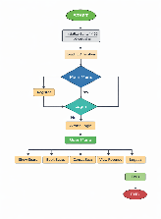
CODE
#include <iostream>
#include <fstream>
#include <vector>
#include <limits>
using namespace std;

class Employee {
public:
int id;
string name;
float salary;

void input() {
cout << "Enter ID: ";
cin >> id;

cin.ignore(numeric_limits<streamsize>::max(), '\n');
cout << "Enter Name: ";
getline(cin, name);

cout << "Enter Salary: ";
cin >> salary;
}

void display() const {
cout << "ID: " << id
<< " | Name: " << name
<< " | Salary: " << salary << endl;
}
};

// Load data from file
void loadFromFile(vector<Employee> &empList) {
ifstream file("employees.txt");

if (!file) return; // FIX: file check

Employee e;

while (file >> e.id) {
file.ignore(numeric_limits<streamsize>::max(), '\n');
getline(file, e.name);
file >> e.salary;
file.ignore(numeric_limits<streamsize>::max(), '\n');
empList.push_back(e);
}

file.close();
}

// Save data to file
void saveToFile(const vector<Employee> &empList) {
ofstream file("employees.txt");

for (const auto &e : empList) {
file << e.id << endl;
file << e.name << endl;
file << e.salary << endl;
}

file.close();
}

// Add Employee
void addEmployee(vector<Employee> &empList) {
Employee e;
e.input();
empList.push_back(e);
saveToFile(empList);
cout << "Employee added successfully!\n";
}

// Display Employees
void displayEmployees(const vector<Employee> &empList) {
if (empList.empty()) {
cout << "No records found!\n";
return;
}

for (const auto &e : empList) {
e.display();
}
}

// Delete Employee
void deleteEmployee(vector<Employee> &empList) {
int id;
cout << "Enter ID to delete: ";
cin >> id;

for (auto it = empList.begin(); it != empList.end(); ++it) {
if (it->id == id) {
empList.erase(it);
saveToFile(empList);
cout << "Employee deleted successfully!\n";
return;
}
}

cout << "Employee not found!\n";
}

// Update Employee
void updateEmployee(vector<Employee> &empList) {
int id;
cout << "Enter ID to update: ";
cin >> id;

for (auto &e : empList) {
if (e.id == id) {
cin.ignore(numeric_limits<streamsize>::max(), '\n');

// cout << "Enter new name: ";
// getline(cin, e.name);

cout << "Enter new salary: ";
cin >> e.salary;

saveToFile(empList);
cout << "Employee updated successfully!\n";
return;
}
}

cout << "Employee not found!\n";
}

// Main Function
int main() {
vector<Employee> empList;
loadFromFile(empList);

int choice;

do {
cout << "\n===== Employee Management System =====\n";
cout << "1. Add Employee\n";
cout << "2. Display Employees\n";
cout << "3. Update Employee\n";
cout << "4. Delete Employee\n";
cout << "5. Exit\n";
cout << "Enter choice: ";
cin >> choice;

switch (choice) {
case 1: addEmployee(empList); break;
case 2: displayEmployees(empList); break;
case 3: updateEmployee(empList); break;
case 4: deleteEmployee(empList); break;
case 5: cout << "Exiting...\n"; break;
default: cout << "Invalid choice!\n";
}

} while (choice != 5);

return 0;
}

BIBLIOGRAPHY

- Balagurusamy, E., Programming in ANSI C++, McGraw Hill Education.

- Official C++ Documentation – https://cplusplus.com

- Microsoft Documentation – https://learn.microsoft.com

- Lecture Notes provided by Faculty

